**Assignment on Collection Framwork**

**Q1.Why collection framework in java**

**Ans:**

The Java Collections Framework provides a comprehensive set of classes and interfaces to handle and manipulate groups of objects. It offers several benefits:

1. *Reusable Data Structures:* The framework includes commonly used data structures like lists, sets, maps, queues, etc. These structures are implemented in a generic and reusable way, saving developers from reinventing the wheel for each project.

2. *Consistency:* The framework establishes a uniform and consistent interface for various data structures. This consistency makes it easier for developers to learn and use different collections.

3. *Interoperability:* Collections can work seamlessly with each other, allowing developers to switch between different data structures without major code changes. For example, you can easily change from using an ArrayList to a LinkedList without modifying the rest of your code.

4. *Algorithms:* The framework provides standard algorithms (sorting, searching, etc.) that work on any collection, promoting code reuse and reducing the need for developers to implement these algorithms from scratch.

5. *Performance:* The implementations in the Collections Framework are well-optimized, providing efficient data manipulation operations.

6. *Thread-Safety:* It includes synchronized versions of collections, making it easier to create thread-safe applications when needed.

In essence, the Java Collections Framework simplifies the process of working with collections of objects, offering a standardized way to handle, store, and process data in Java applications

**Q2What is Collection interface?**

**Ans:**

The `Collection` interface in Java is the root interface of the Java Collections Framework. It extends the `Iterable` interface and represents a group of objects, known as elements. It defines the fundamental methods that all collections will have.

Here are some of the key methods declared in the `Collection` interface:

1. `int size()`: Returns the number of elements in the collection.

2. `boolean isEmpty()`: Returns `true` if the collection contains no elements.

3. `boolean contains(Object element)`: Returns `true` if the collection contains the specified element.

4. `Iterator<E> iterator()`: Returns an iterator over the elements in the collection.

5. `boolean add(E element)`: Adds the specified element to the collection.

6. `boolean remove(Object element)`: Removes the specified element from the collection.

7. `boolean containsAll(Collection<?> c)`: Returns `true` if the collection contains all the elements in the specified collection.

8. `boolean addAll(Collection<? extends E> c)`: Adds all the elements from the specified collection to the collection.

9. `boolean removeAll(Collection<?> c)`: Removes all the elements in the specified collection from the collection.

10. `void clear()`: Removes all elements from the collection.

The `Collection` interface is the foundation for more specific interfaces like `List`, `Set`, and `Queue`, each tailored to different types of collections. Classes that implement the `Collection` interface provide concrete implementations of these methods based on the specific characteristics of the collection they represent.

**Q3what is package of collection framework?**

**Ans:**

The Java Collections Framework is part of the `java.util` package. The classes and interfaces related to collections, such as `List`, `Set`, `Map`, and various utility classes, are all part of this package.

For example, commonly used classes like `ArrayList`, `LinkedList`, `HashSet`, `HashMap`, and many others are part of the `java.util` package. When working with collections in Java, you typically import classes and interfaces from this package to use their functionalities in your code.

**Q4.which is root interface of Collection Framework?**

**Ans:**

The root interface of the Java Collections Framework is the `Collection` interface. This interface is the top-level interface in the hierarchy and provides the basic structure and methods that are common to all collections in Java, including lists, sets, and queues. Other more specific interfaces like `List`, `Set`, and `Queue` extend the `Collection` interface.

**Q5List the subinterface of Collection interface.**

**Ans:**

Several subinterfaces extend the `Collection` interface in the Java Collections Framework. Here are some of the main subinterfaces:

1. *List:* Represents an ordered collection and allows duplicate elements. Implementations include `ArrayList`, `LinkedList`, and `Vector`.

2. *Set:* Represents an unordered collection of unique elements. Implementations include `HashSet`, `LinkedHashSet`, and `TreeSet`.

3. *Queue:* Extends `Collection` and adds methods specific to collections designed for holding elements before processing. Implementations include `LinkedList` and various specialized queues.

4. *Deque (Double-ended queue):* Extends `Queue` and allows elements to be added or removed from both ends. Implementations include `ArrayDeque`.

5. *Map:* Represents a collection of key-value pairs. Implementations include `HashMap`, `TreeMap`, and `LinkedHashMap`.

These subinterfaces provide specialized functionality and characteristics for different types of collections, catering to various use cases in Java programming.

**Q6List out the classes which are implementing the List interface and Set Interface and Collection interface.**

**Ans:**

Sure, here are some of the commonly used classes that implement the `List`, `Set`, and `Collection` interfaces in the Java Collections Framework:

### Implementing `List` Interface:

1. *ArrayList:* Resizable array implementation of the `List` interface.

2. *LinkedList:* Doubly-linked list implementation of the `List` interface.

3. *Vector:* Similar to `ArrayList` but is synchronized.

4. *Stack:* A subclass of `Vector` that represents a last-in, first-out (LIFO) stack of objects.

### Implementing `Set` Interface:

1. *HashSet:* Implements a hash table for fast retrieval.

2. *LinkedHashSet:* Maintains order of insertion while also using a hash table.

3. *TreeSet:* Implements a sorted set using a tree structure.

### Implementing `Collection` Interface:

1. *ArrayList, LinkedList, Vector, Stack:* As mentioned earlier, these classes also implement the `Collection` interface.

2. *HashSet, LinkedHashSet, TreeSet:* These set implementations also implement the `Collection` interface.

3. *HashMap, LinkedHashMap, TreeMap:* Classes implementing the `Map` interface, which is not a direct subinterface of `Collection`, but they are part of the collections framework and provide key-value pair storage.

These are just a few examples, and there are other classes and implementations available in the Java Collections Framework depending on your specific needs and requirements.

**Q7Write a small program for adding one integer, float, double, char, string, short, boolean, byte object to list and set interface.**

**Ans:**

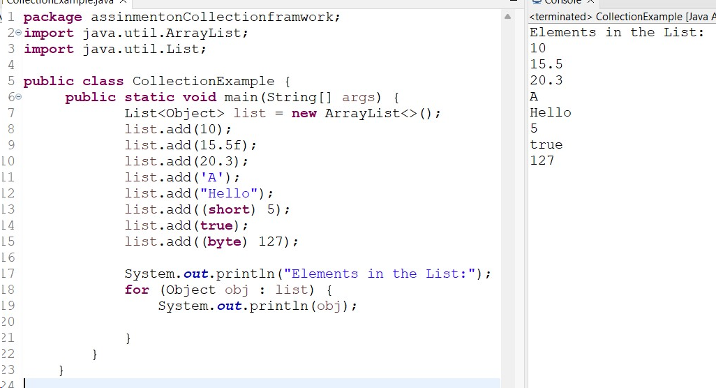

**Q8Write a program to read and print the file properties like name**

**of the file, size,author,dateofcreation and dateofupdation using**

**Properties class of collection framework.**

**Ans:**

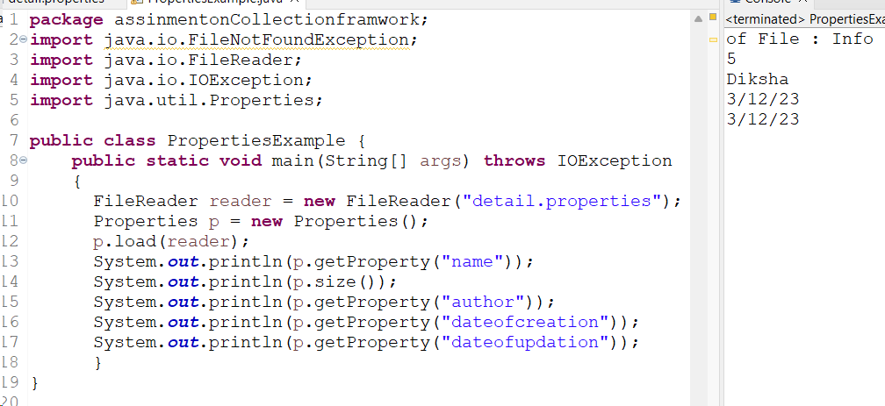

**Q9. Diffence between the List and Set**

**Ans:**

The main difference between a List and a Set lies in their characteristics. A List is an ordered collection that allows duplicate elements, meaning you can have multiple identical items in a list, and their order is preserved. On the other hand, a Set is an unordered collection that doesn't allow duplicates, ensuring unique elements.

In summary, Lists maintain order and permit duplicates, while Sets are unordered and enforce uniqueness.

**10. Diffeence between ArrayList and LinkedList**

**Ans:**

The key difference between ArrayList and LinkedList lies in their underlying data structures and the way elements are stored.

1. *Underlying Data Structure:*

- *ArrayList:* It uses a dynamic array to store elements, allowing fast random access and efficient element retrieval.

- *LinkedList:* It uses a doubly-linked list, providing quick insertion and deletion at the cost of slower random access.

2. *Access Time:*

- *ArrayList:* Offers fast random access as elements are stored in contiguous memory locations. Accessing an element by index is efficient.

- *LinkedList:* Provides fast insertion and deletion, especially in the middle of the list, but accessing elements by index is slower compared to ArrayList.

3. *Memory Overhead:*

- *ArrayList:* Generally has less memory overhead per element as it only needs to store the data and the array size.

- *LinkedList:* Has higher memory overhead because it needs to store references to the next and previous elements in addition to the data itself.

4. *Insertion and Deletion:*

- *ArrayList:* Insertion and deletion operations can be slower, especially when done frequently or in the middle of the list, as elements may need to be shifted.

- *LinkedList:* Provides faster insertion and deletion, especially in the middle, as it involves updating the pointers of neighboring elements.

In summary, use ArrayList when you need fast random access and infrequent insertions/deletions, and use LinkedList when you require efficient insertions/deletions, particularly in the middle of the collection. Each has its strengths depending on the specific requirements of your application.

**11. Difference between HashMap and HashSet**

**Ans:**

The main difference between HashMap and HashSet lies in their purpose and the way they store and manage elements:

1. *Purpose:*

- *HashMap:* It is used to store key-value pairs, where each key is associated with a specific value. It allows fast retrieval of values based on their keys.

- *HashSet:* It is used to store a collection of unique elements. It does not allow duplicate elements, making it suitable for scenarios where uniqueness is essential.

2. *Underlying Data Structure:*

- *HashMap:* It uses a hash table to store key-value pairs. This enables efficient retrieval of values based on their keys.

- *HashSet:* It uses a hash table internally to ensure uniqueness of elements. Each element is hashed to determine its position in the underlying data structure.

3. *Elements:*

- *HashMap:* Consists of key-value pairs, and each key is associated with a specific value.

- *HashSet:* Contains only unique elements; it does not store key-value pairs, only individual elements.

4. *Use Cases:*

- *HashMap:* Useful when you need to associate values with unique keys and require fast retrieval based on those keys.

- *HashSet:* Suitable when you need to store a collection of unique elements without any associated values.

In summary, HashMap is designed for key-value pair associations, providing efficient key-based retrieval, while HashSet is designed for maintaining a collection of unique elements, ensuring that no duplicates are present.

**12. Difference between the Iterator and ListIterator**

**Ans:**

1. *Collections:*

- `Iterator` can be used to iterate over any collection (like sets, lists, and maps) using the `Iterator` interface.

- `ListIterator` is specific to List implementations, like ArrayList or LinkedList.

2. *Direction:*

- `Iterator` allows forward-only traversal, meaning you can only move forward in the collection.

- `ListIterator` extends `Iterator` and provides bidirectional traversal, allowing movement both forward and backward in the list.

3. *Methods:*

- `ListIterator` has additional methods like `previous()`, `hasPrevious()`, `nextIndex()`, and `previousIndex()` that are not present in the basic `Iterator`.

4. *Modification:*

- Both iterators allow removal of elements during iteration using the `remove()` method, but only `ListIterator` allows adding elements at the current position with `add()`.

**13.Write a program to write employee object to the file and read it.**

**Ans:**

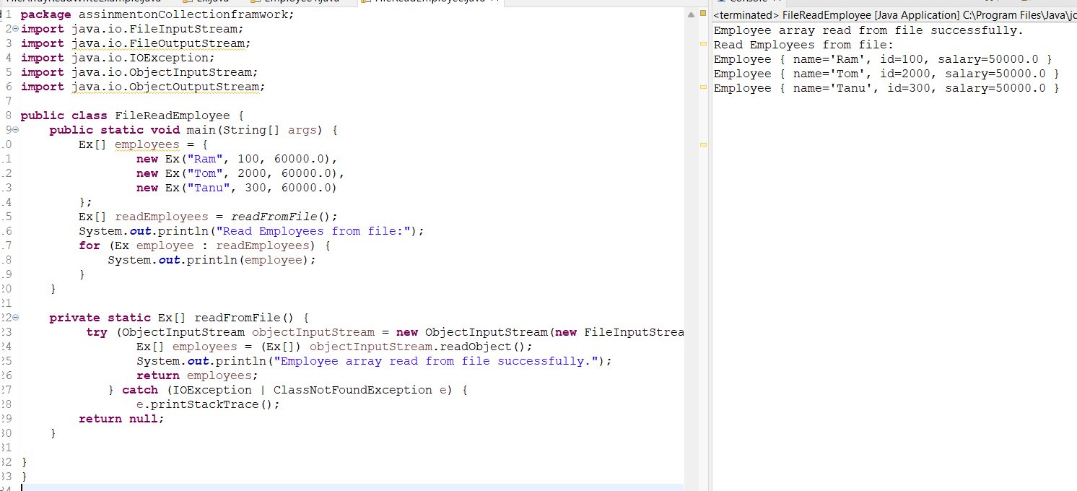

**14.Write a program to write employee array of objects to the file and read it.**

**Ans:**

